HOW TO BUILD A VOTEFEST
A Replication Guide for Indivisible Groups

What Is VOTEFEST?
VOTEFEST is a community voter-engagement festival designed to make voting, civic participation and organizing visible, social, creative and inviting. Queens Says NO KINGS developed VOTEFEST as a prototype: create the model, test it in the community, improve it, and then make it possible for other groups to replicate it.
A VOTEFEST is more than a voter-registration table and more than a festival with voting information added to it. The goal is not simply to tell people to vote. It is to help people want to participate, know how to participate, and find a place in the community that continues after Election Day.
VOTEFEST is designed for nonpartisan voter engagement. Participating organizations may have their own missions and policy positions, but VOTEFEST voter-engagement programming should remain focused on participation, voting access, democracy and community action rather than promoting or opposing individual candidates. This makes it possible to partner with 501c3 organizations such as the League of Women Voters, HeadCount, Common Cause, NYCLU and faith organizations.

WHAT MAKES IT A VOTEFEST?
The VOTEFEST model works because several things happen together.
ENGAGE People have conversations about voting and participation.
ASSIST People can get practical help overcoming barriers to voting.
ACTIVATE People leave knowing something concrete they can do next.
CONNECT Organizations work together instead of operating in isolation.
CREATE People participate in the art and help make something together.
CELEBRATE Music, art, food and community make civic participation enjoyable.
CONTINUE The festival leads to additional voter outreach, election protection, volunteering and organizing.
These elements can be adapted to the size and personality of your community, but together they create the full VOTEFEST experience.

THE VOTEFEST MODEL

1. Voter Registration

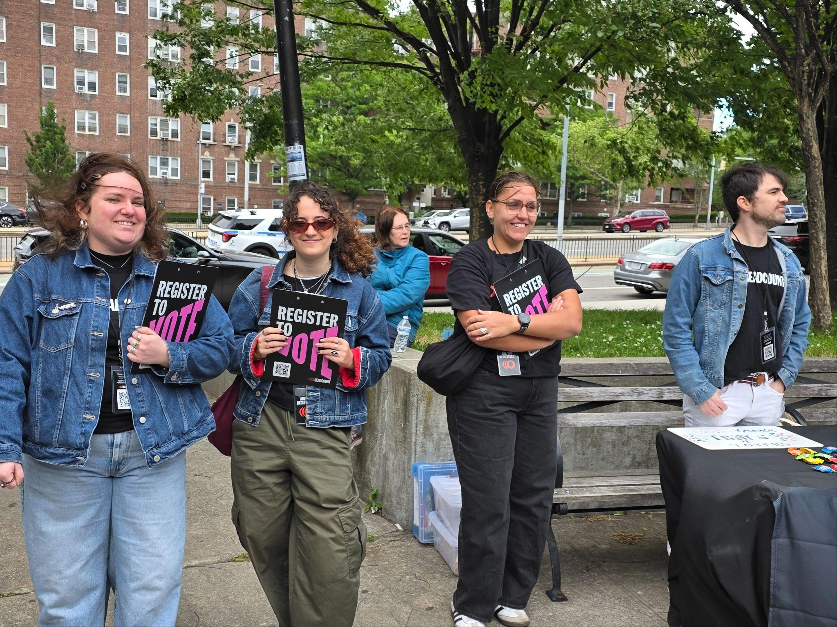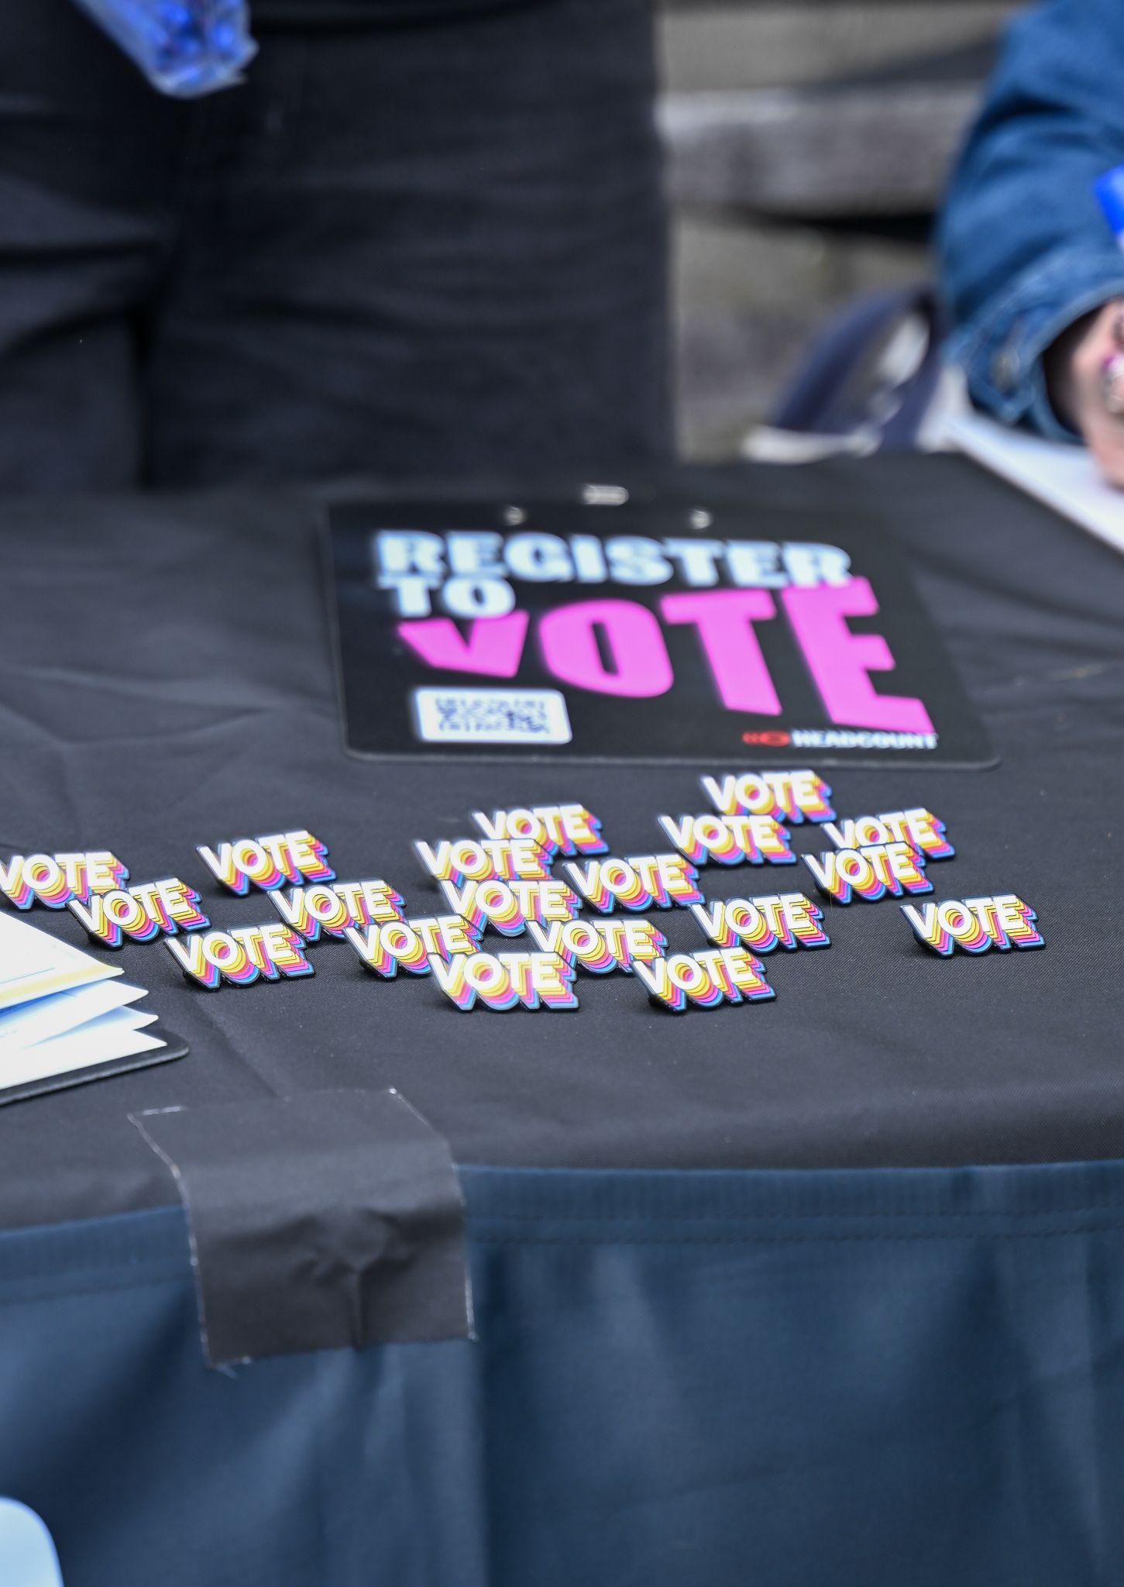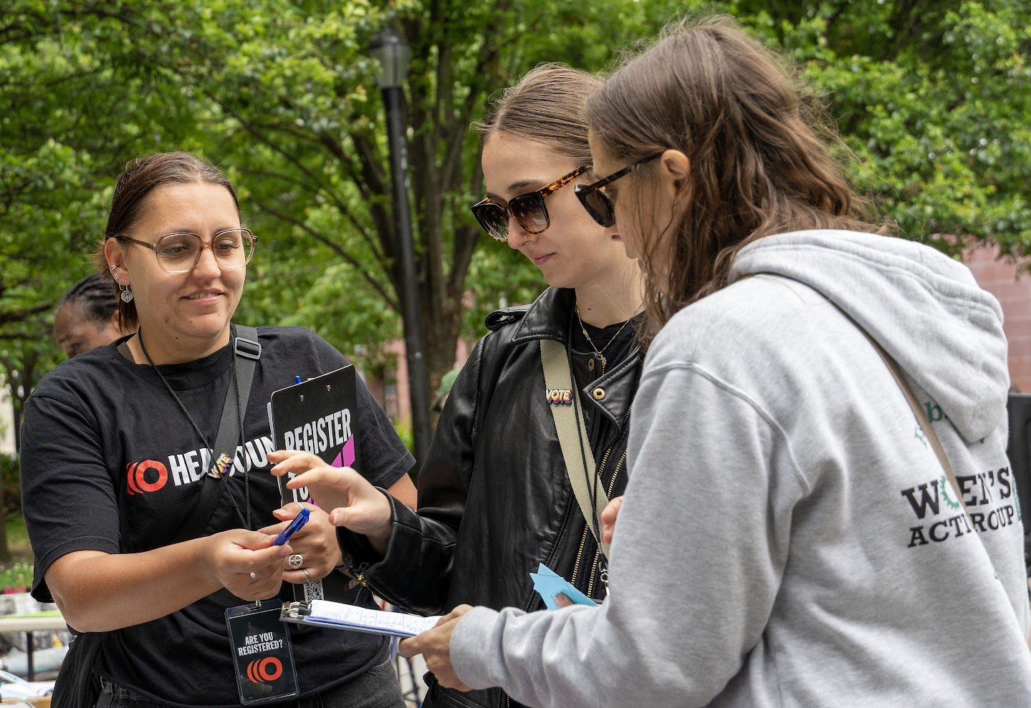
Every VOTEFEST should provide a clear place where people can:
- register to vote
- check or update their registration
- get accurate information about registration deadlines
- find official voting information
Whenever possible, partner with an organization experienced in voter registration, such as HeadCount or the League of Women Voters.
Training your own volunteers is possible, but experienced voter-registration organizations do this work every day and will generally do it better.
Registration should be easy to find, but it should not dominate the entire event. Many people attending VOTEFEST will already be registered. We want something meaningful for them to do too.

2. Make a Voting Plan
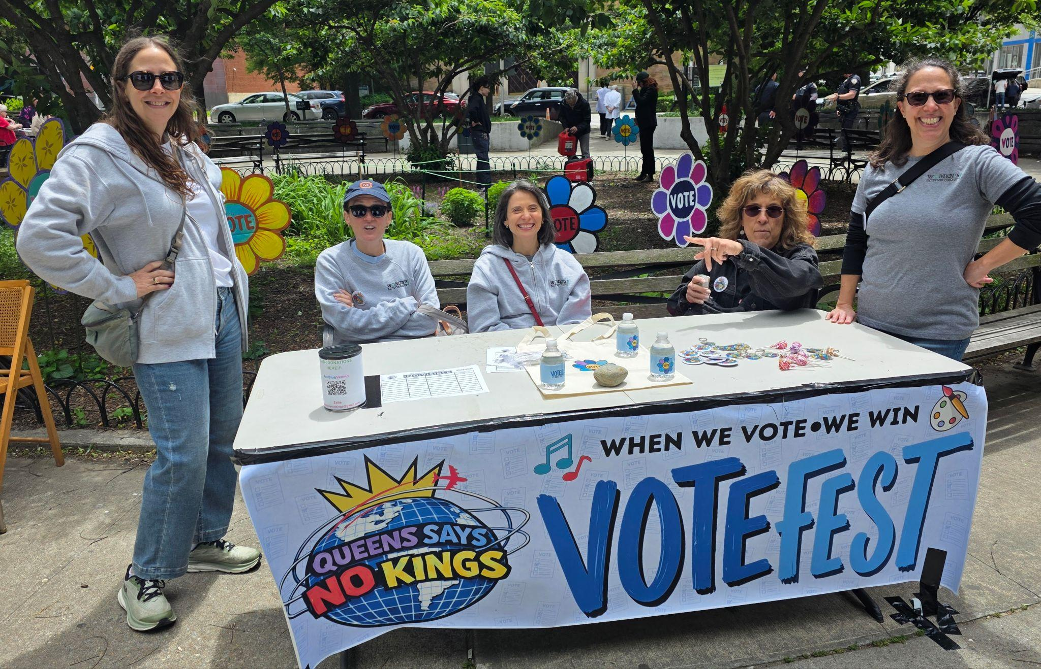
This is one of the most important differences between VOTEFEST and a traditional voter-registration drive.
People should be encouraged to make an actual voting plan:
When will I vote?
Where will I vote?
Will I vote early, by mail or on Election Day?
How will I get there?
Is there anything that could make it difficult for me to vote?
This can be handled by HeadCount, the League of Women Voters, etc. or by volunteers.

3. Voting Assistance and Accessibility

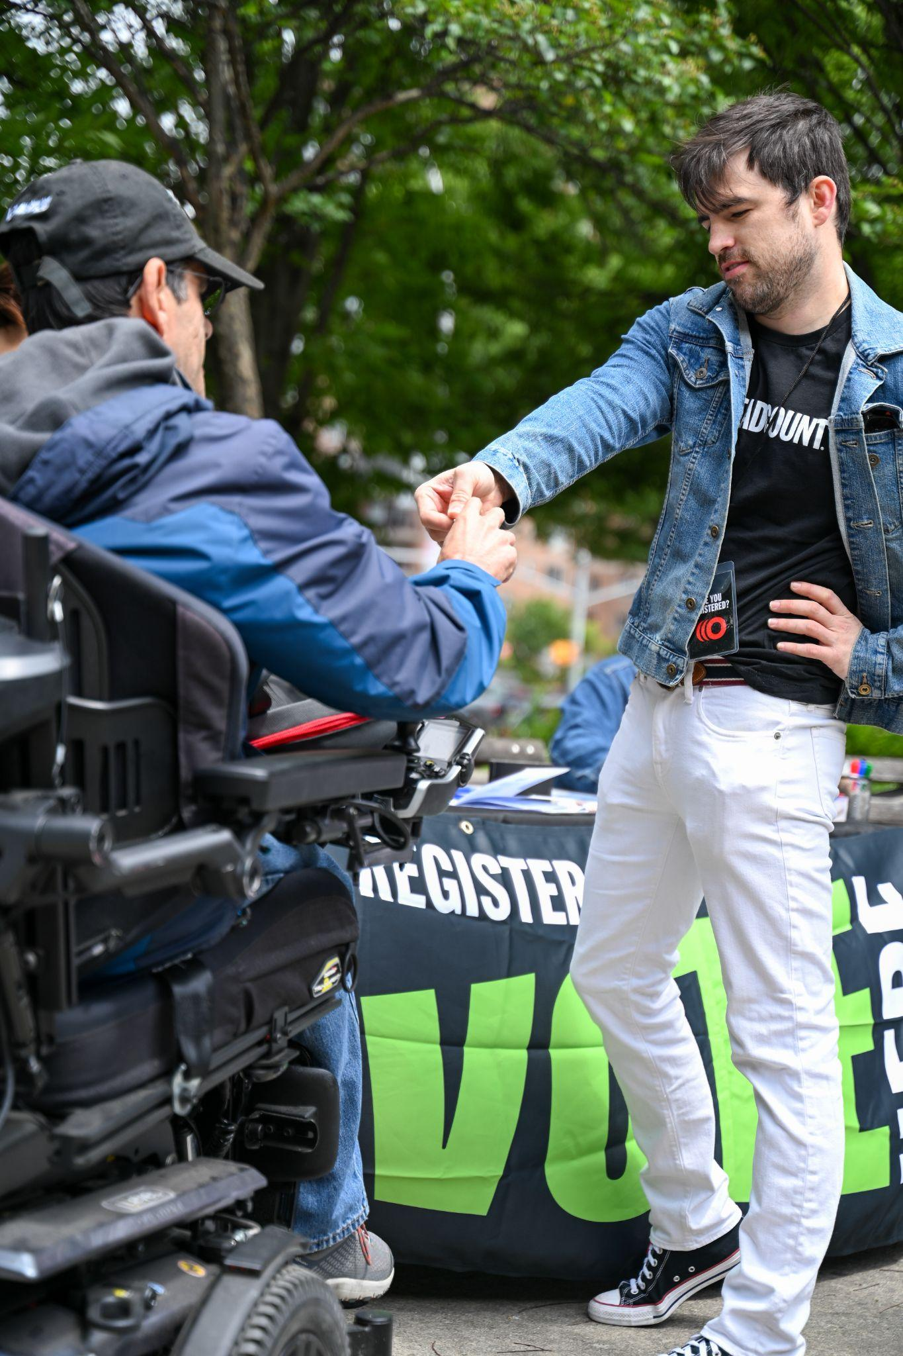
VOTEFEST should recognize that voting is easier for some people than for others. Include information and, when possible, an experienced partner that can assist:
- seniors
- people with disabilities
- people who need accessible polling locations or voting equipment
- voters with language-access needs
- people who need help understanding voting procedures
A disability-rights organization such as CIDNY - Center for Independence of the Disabled, New York - can provide particularly valuable expertise.
If something makes voting difficult for you, there are people who can help.

4. Election Protection
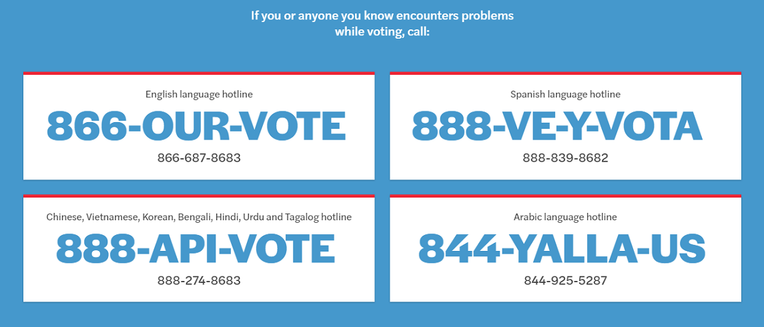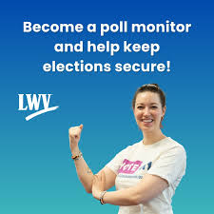
Voters should know what to do if something goes wrong. Election-protection organizations can provide information about:
- voter rights
- poll monitoring
- voter challenges
- accessibility problems
- misinformation
- intimidation
- voting-machine or polling-place problems
- where voters can get reliable help
Potential partners include NYCLU, Common Cause, NAACP, Hands Off and other organizations involved in voter protection. VOTEFEST can also recruit people interested in volunteering for election-protection and poll-monitoring work.

5. Take Action
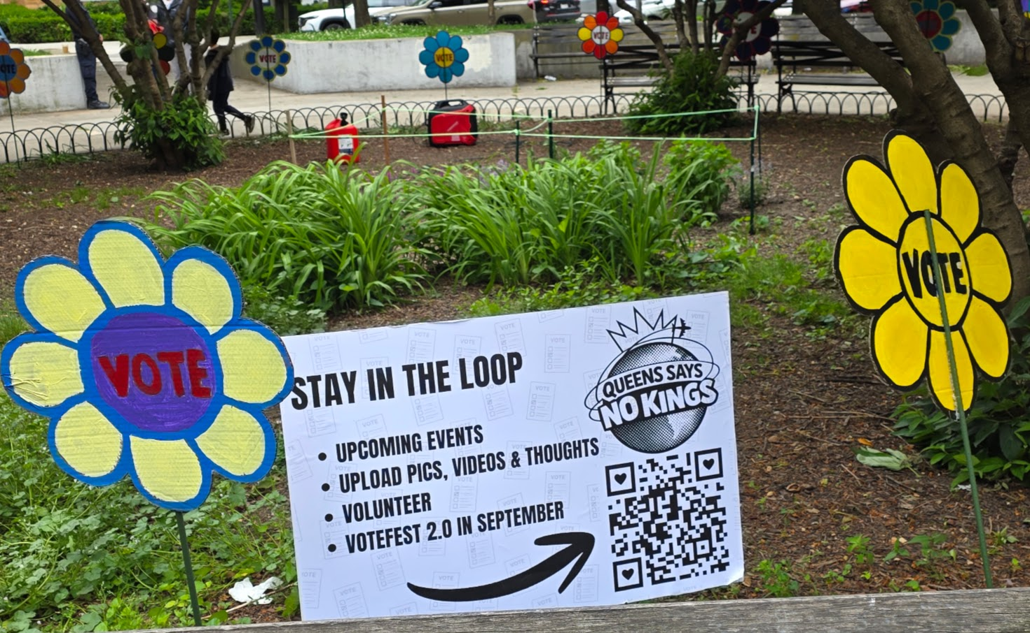
A successful VOTEFEST should offer people a next step.
This is where your own volunteers can invite attendees to join your mailing list, sign up for upcoming events and learn about other organizations doing work they may want to join.
Opportunities might include:
- canvassing and voter outreach
- phone or text banking
- tabling
- election protection
- community safety or rapid-response work
- future voter-engagement events
- volunteering with a participating organization
"Someone came to VOTEFEST excited about participating. What can they actually do next?"
Make those opportunities obvious.

COMMUNITY PARTNERS
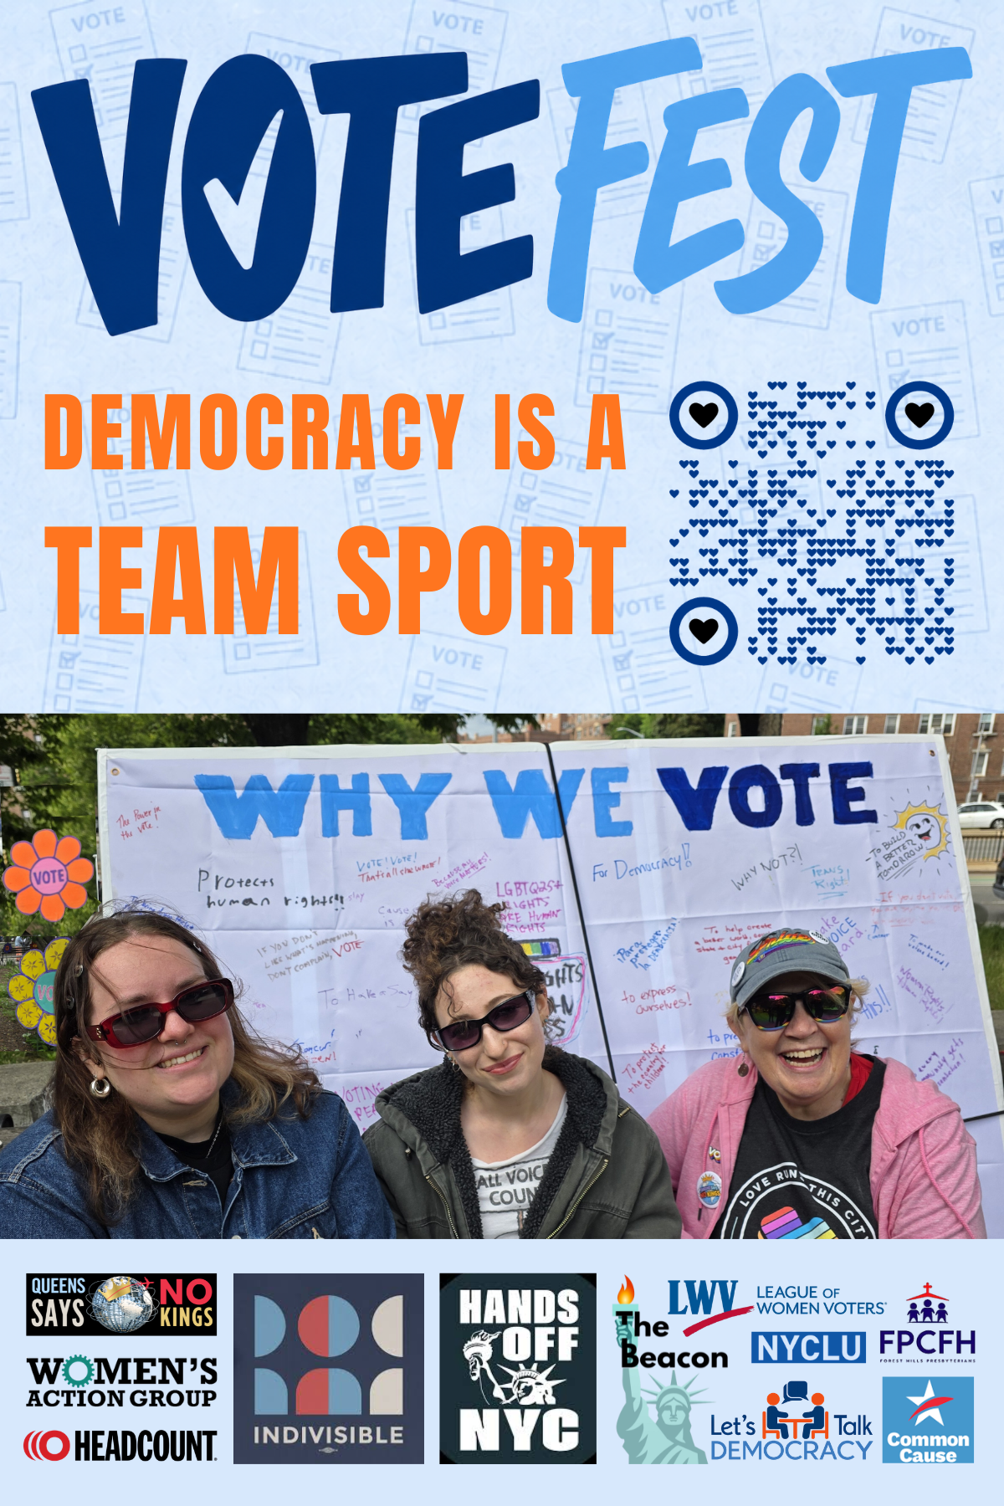
VOTEFEST works best as a coalition event. Look first for partners that bring a specific voter resource or action, not simply another table of literature.
- Indivisible Partners: Queens Says No Kings, Women’s Action Group of Forest Hills, Upper West Side Action Group (UWSAC,) Team Off the Couch.
- League of Women Voters / HeadCount - voter registration, registration checks and voting plans
- NYCLU / Common Cause - voting rights, election protection and voter education
- CIDNY or another disability-rights organization - voting access and assistance for voters with disabilities
- NAACP and other voter-engagement organizations - voter outreach, education and election protection
- Hands Off and other action-oriented groups - concrete ways for people to get involved beyond voting
You can also invite local faith groups, youth organizations, mutual-aid groups, neighborhood associations and other community organizations. These can add local connections and variety to VOTEFEST, but they are optional rather than a core part of the model.
What will someone be able to learn, do or sign up for at your table?

ART IS A CORE PART OF VOTEFEST
Art makes VOTEFEST visible, draws people in, creates strong press and social media images, and gives attendees different ways to participate.
There are three parts to the VOTEFEST art program:

VOTEFEST Visuals
Use bright handmade art throughout the site so people can see VOTEFEST from a distance and immediately recognize it as something different from an ordinary information fair.

VOTE Flowers
Large handmade flowers with VOTE in the center can be placed around entrances, tables and activity areas. Queens Says NO KINGS has VOTE flowers available to loan.
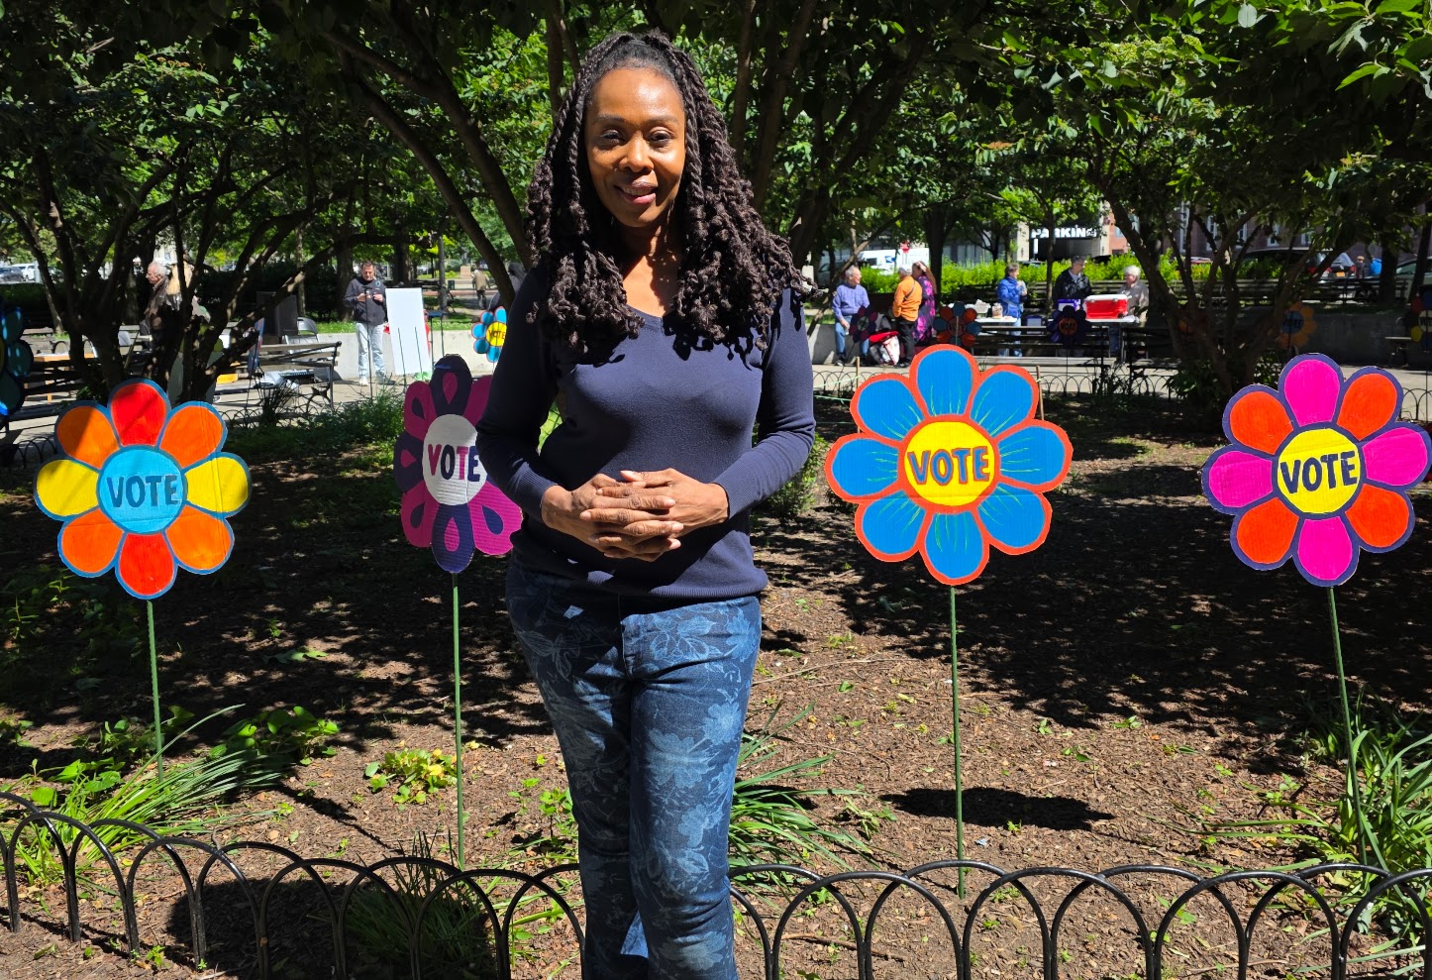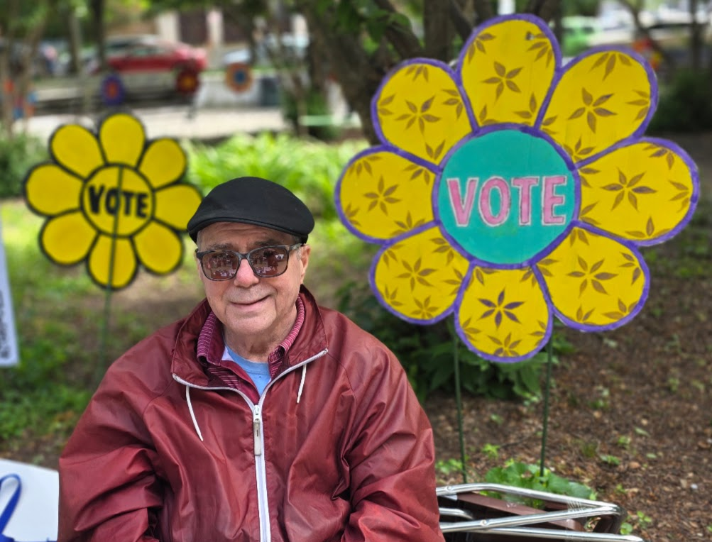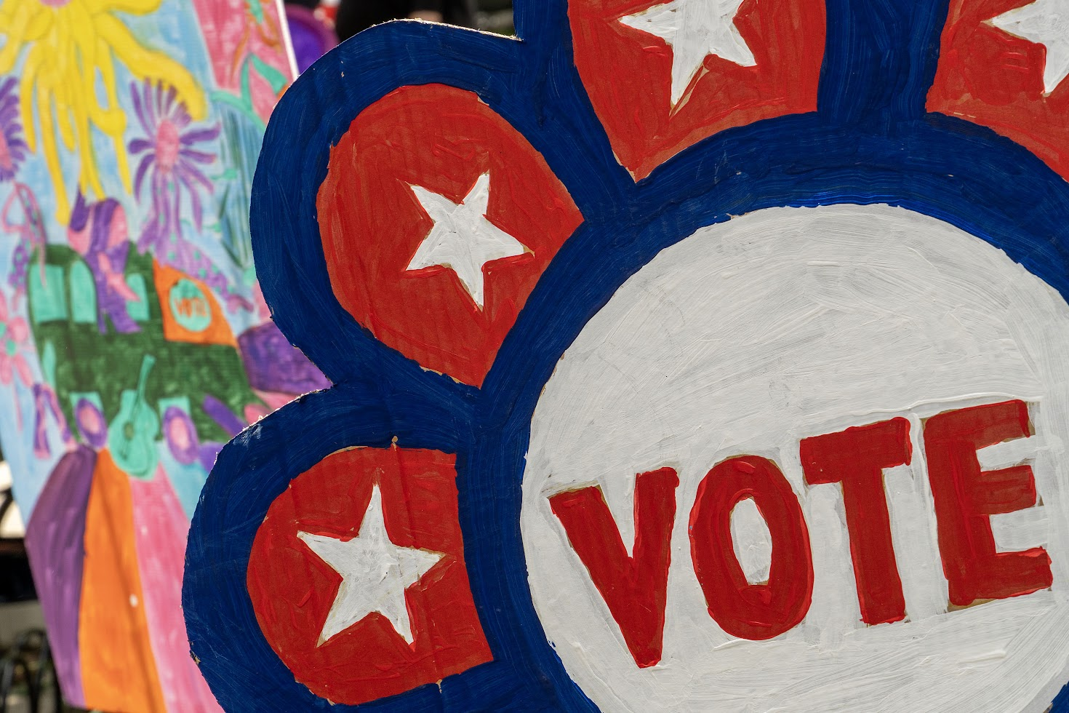

GOTV Signs
Use large, colorful handmade signs throughout the site. We have street sign themed VOTE POWER signs available for loan. (The signs pictured below have not been cut out yet.)

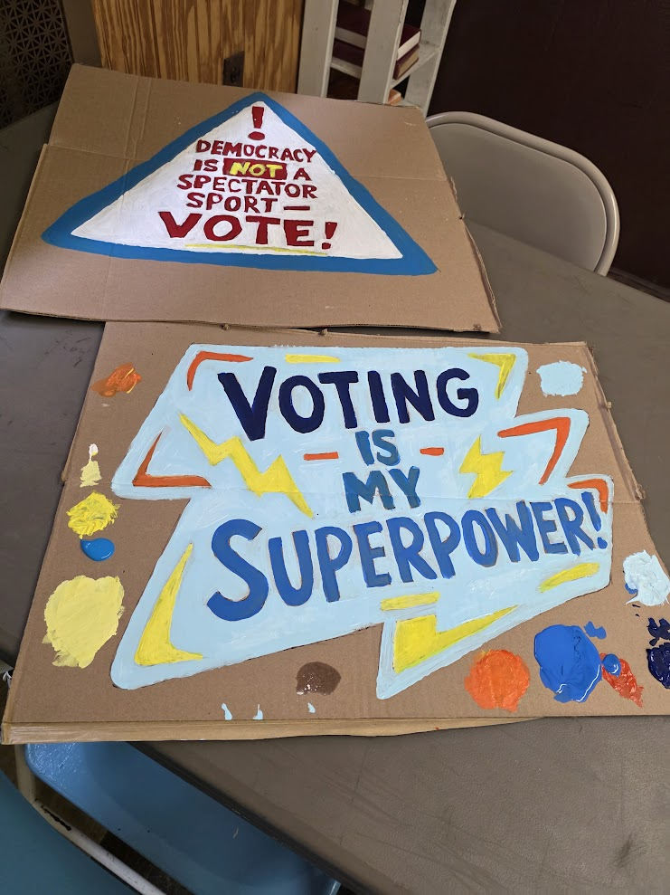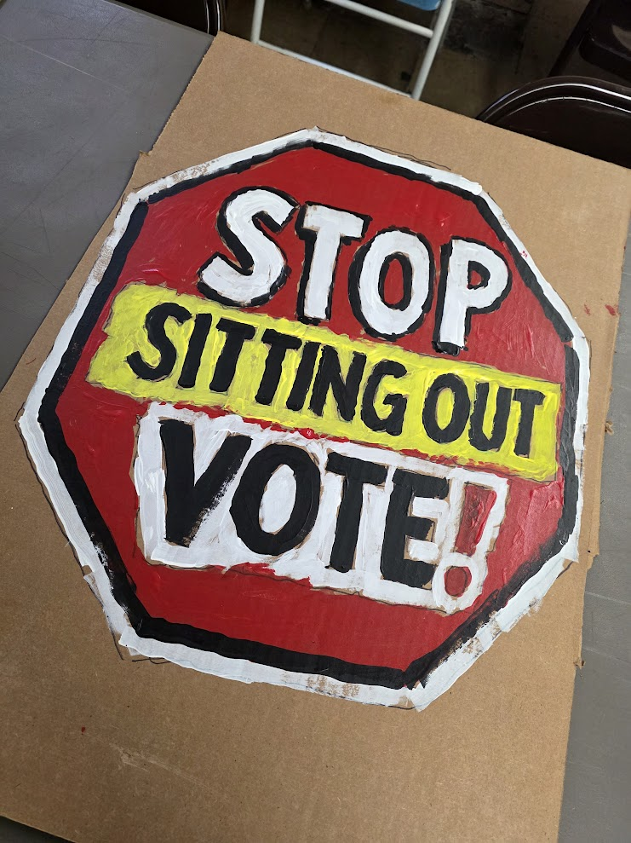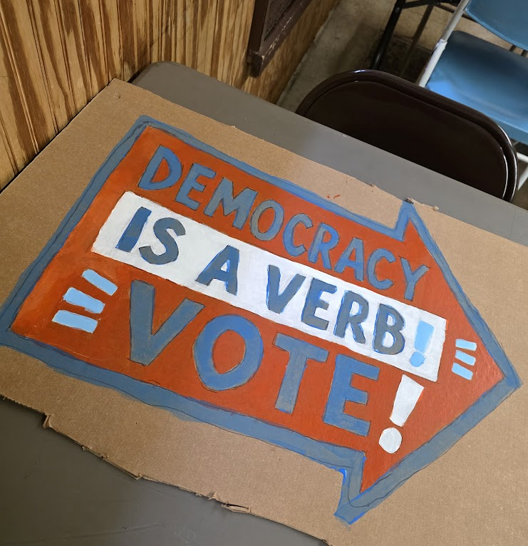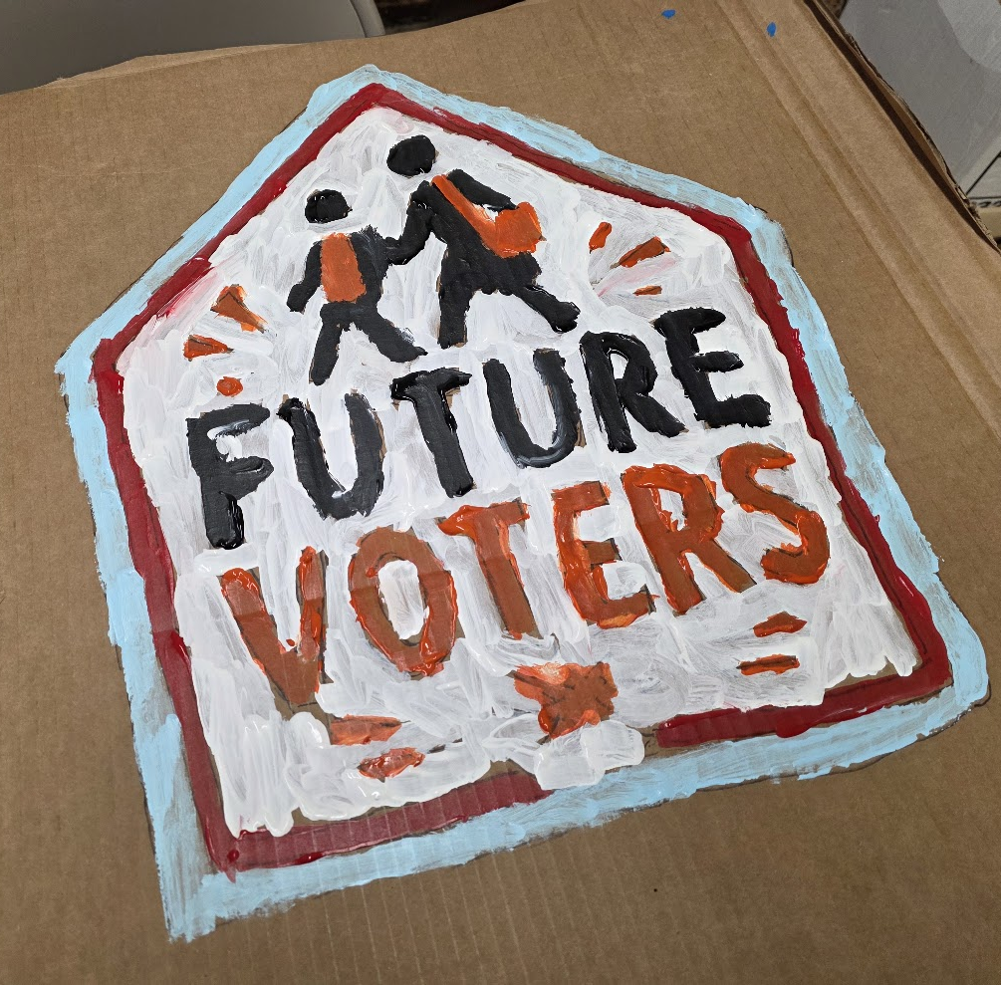

Make Something
Give attendees an opportunity to create something they can take home.

Make Your Own VOTE Button
Set up a button machine with paper circles, markers and a few sample designs.
People can draw their own button, press it and take it home.

Mini VOTE Flowers
Make small take-home versions of the large VOTEFEST VOTE flowers.
Provide pre-cut flower shapes, markers and stems. Attendees decorate their own flower, put VOTE in the center and take it home.
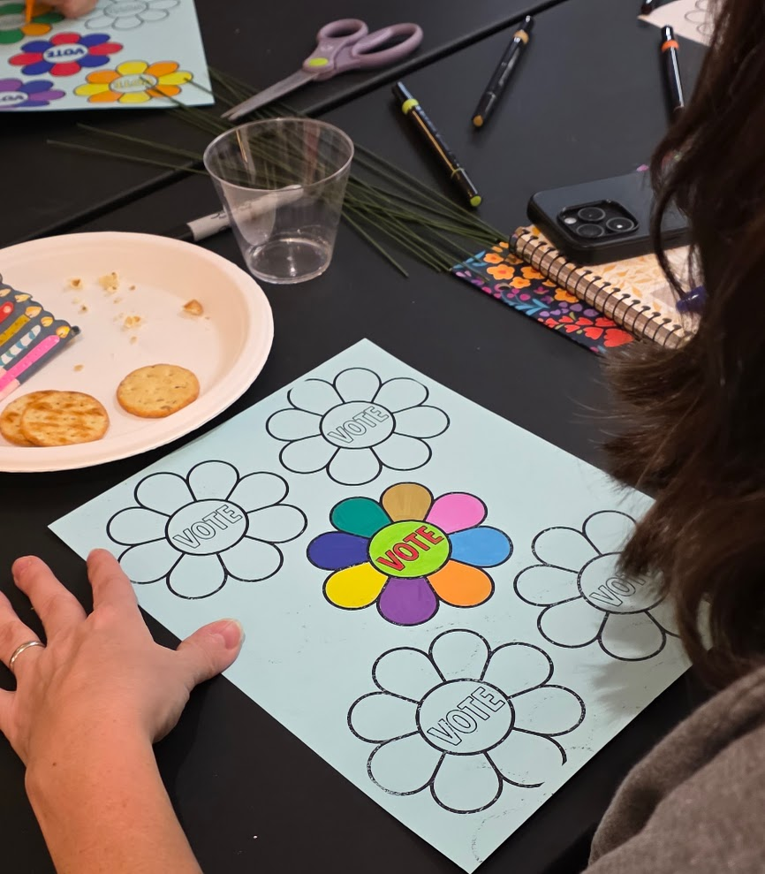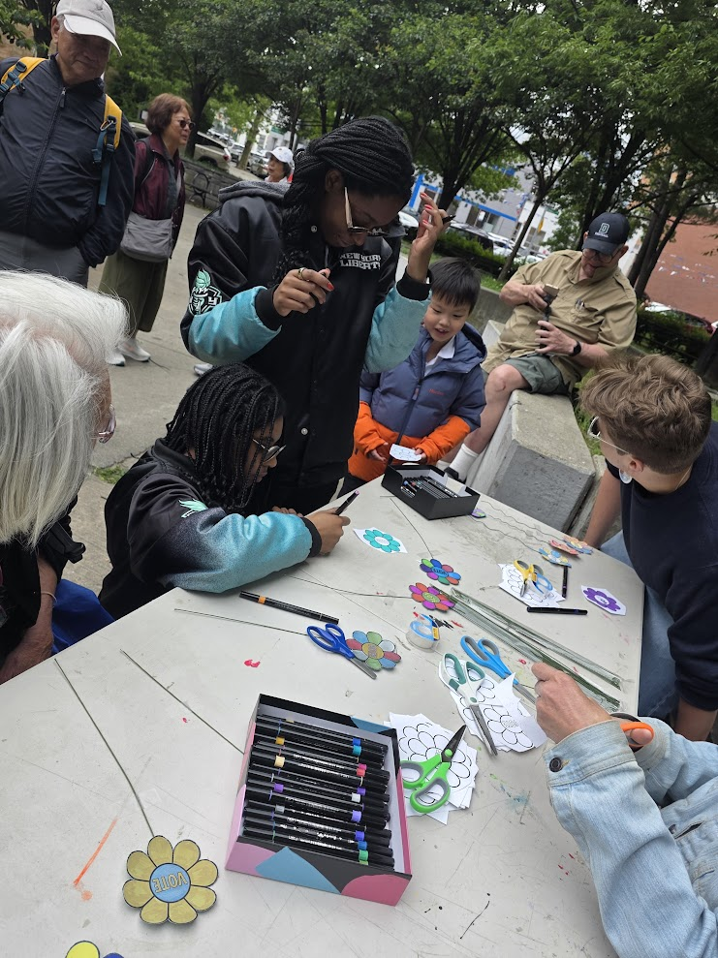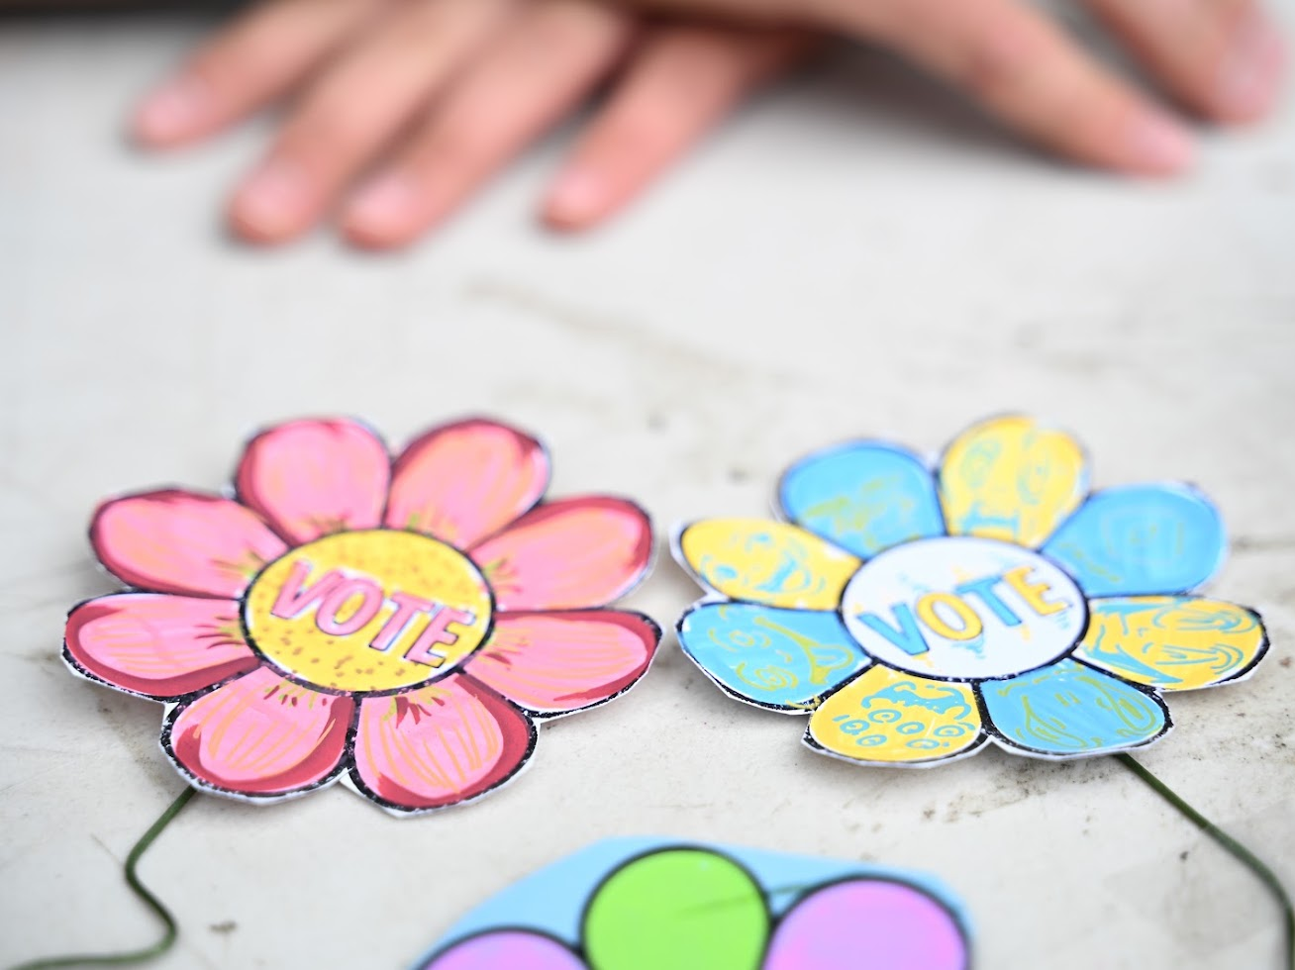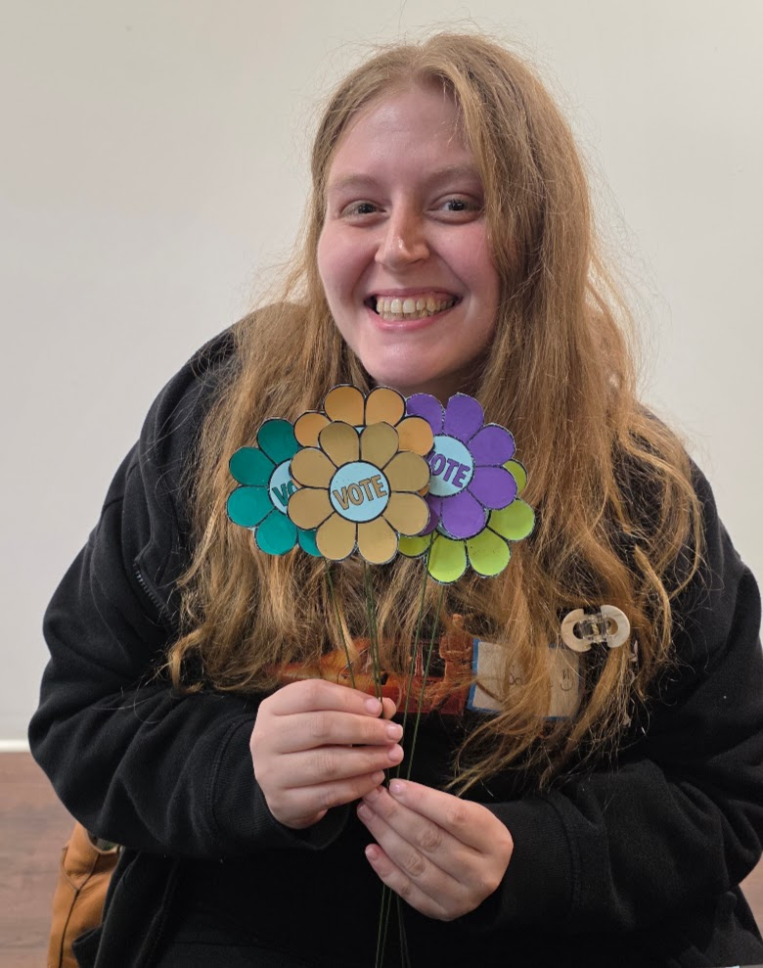

Create Something Together
VOTEFEST should also give attendees a way to contribute to something collective.

WHY WE VOTE Wall
Create a large wall headed WHY WE VOTE. Invite people to write directly on the wall with markers, answering the question in their own words.
As the event continues, the wall fills with personal reasons for voting and becomes a collective statement from the community. Queens Says NO KINGS has developed a structure that allows the WHY WE VOTE wall to be attached to a park bench, making it practical for outdoor VOTEFEST events.
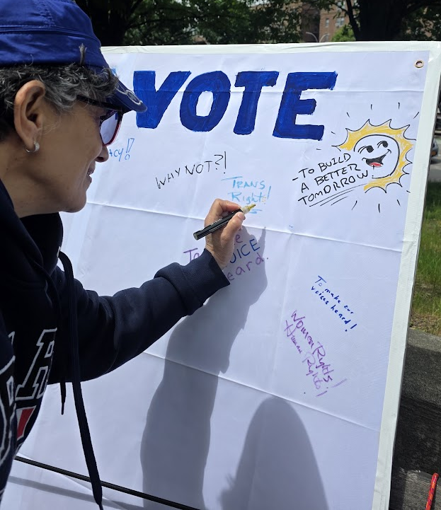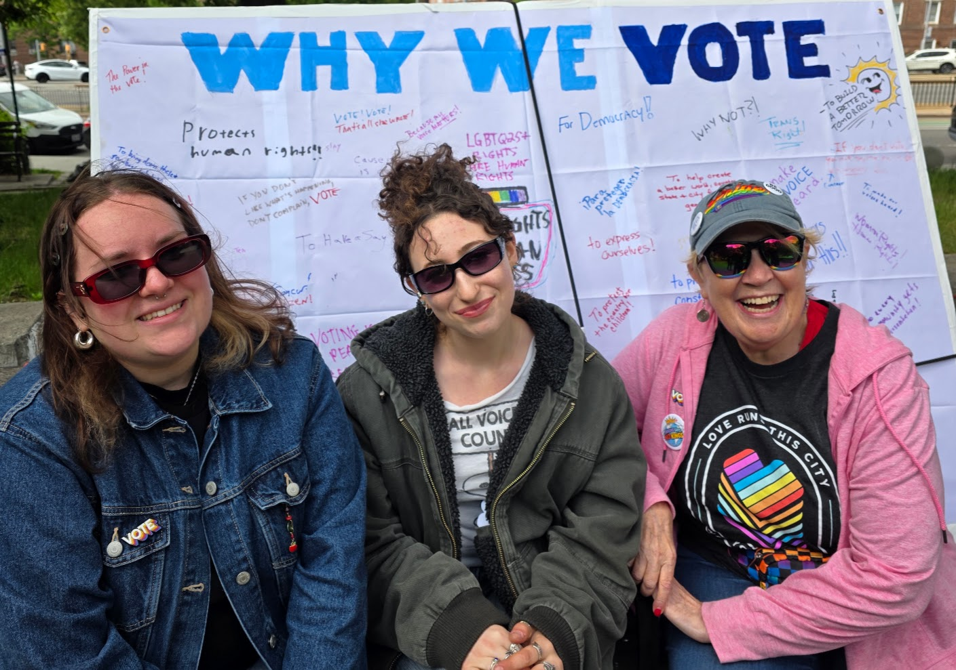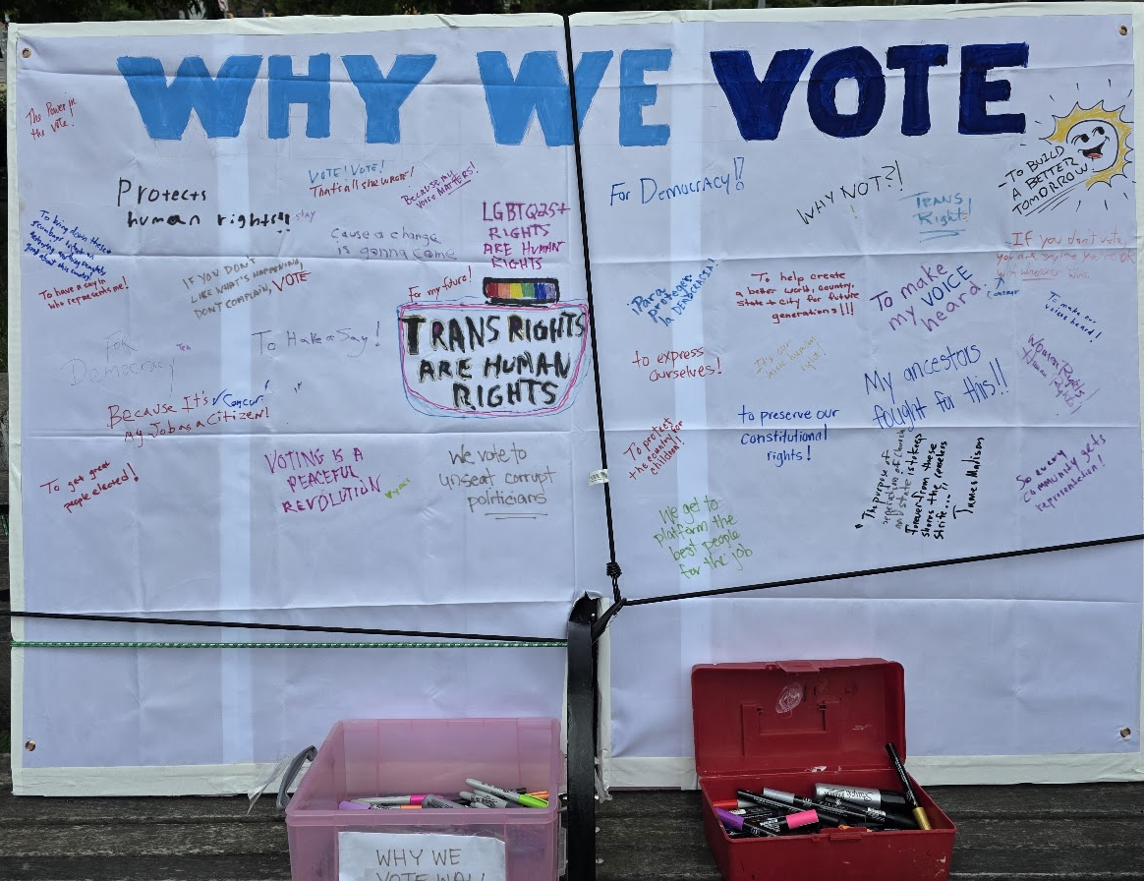

Community Mural
Set up a large collaborative mural that attendees add to throughout VOTEFEST.
Begin with a simple outline or voting-themed design and invite people to add color, words, patterns and images.
By the end of the festival, the mural has become a piece of art created by the community together.
The finished mural can also become part of the artwork displayed at future VOTEFEST events.
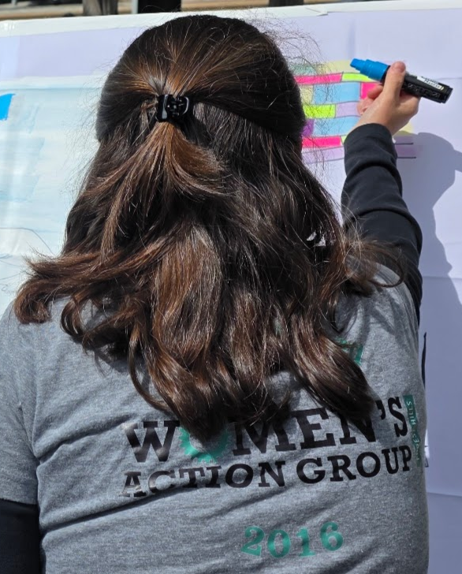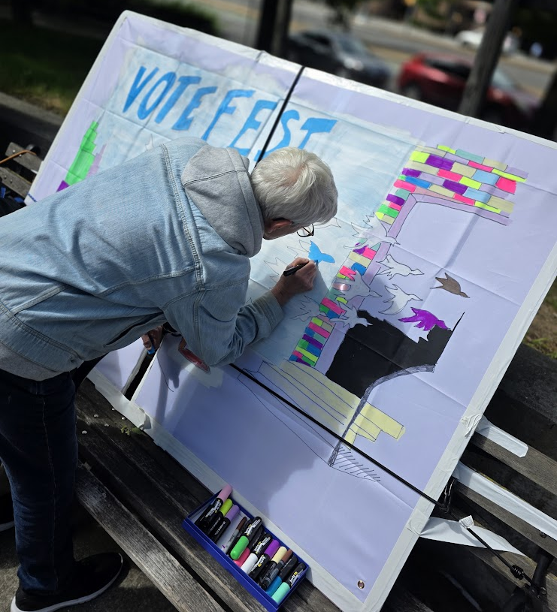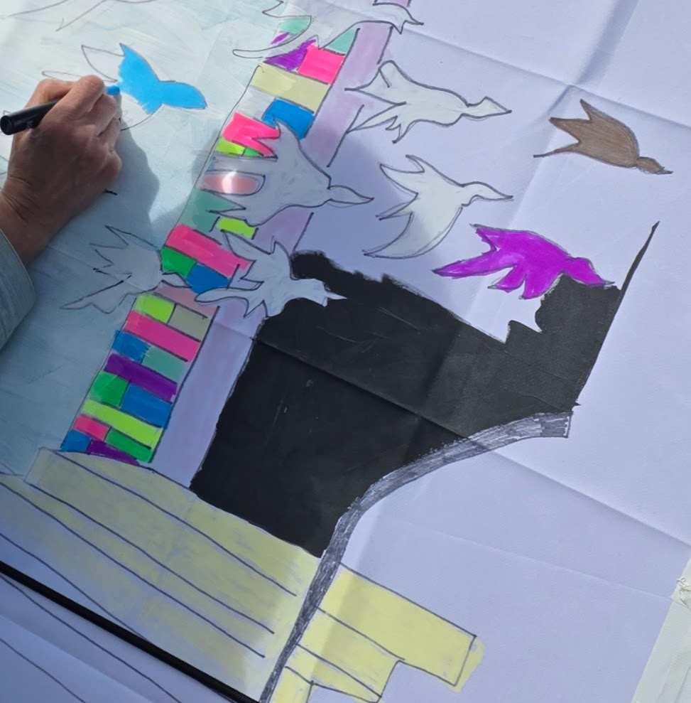

HOLD AN ART BUILD BEFORE VOTEFEST
Most of the VOTEFEST artwork should be made before the event, not during it.
Whenever possible, hold a community Art Build one or more weeks before VOTEFEST.
An Art Build can produce:
- large GOTV and VOTEFEST signs
- additional VOTE flowers
- the base for the community mural
- other colorful pieces needed for the site
Use examples so volunteers have ideas to work from. No art experience should be required.
The Art Build also:
- recruits volunteers
- gives new people an easy first activity
- builds community before the main event
- generates photographs and video for promotion
- gives organizers another opportunity to promote VOTEFEST
The resulting artwork can be reused at future events.
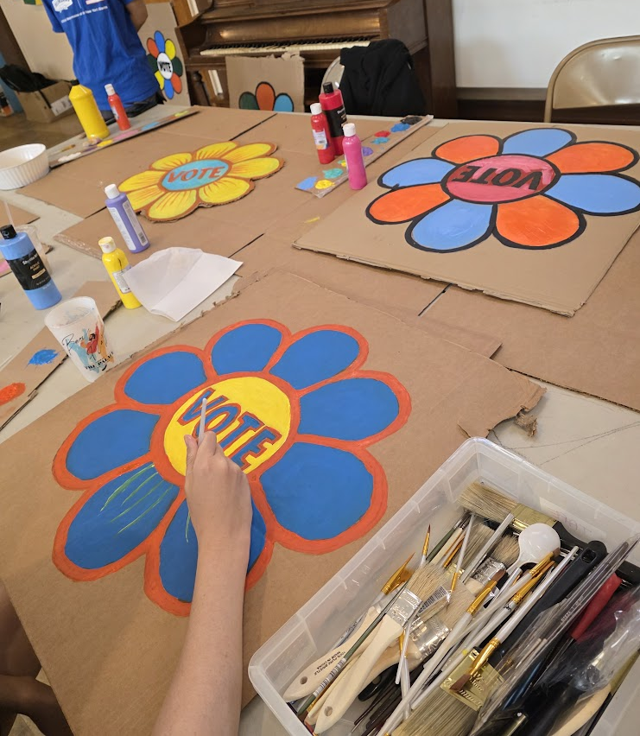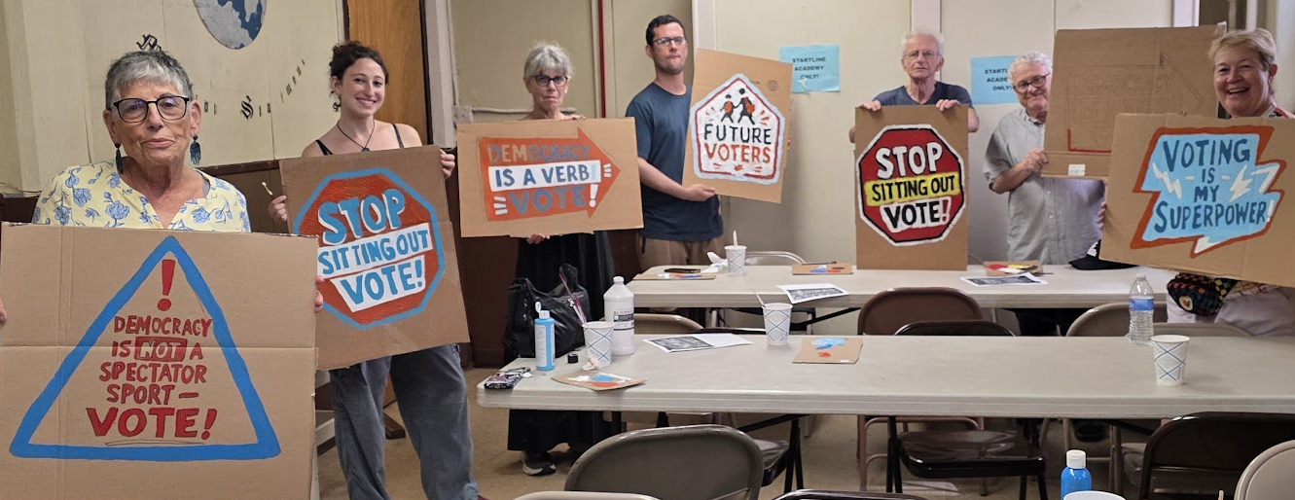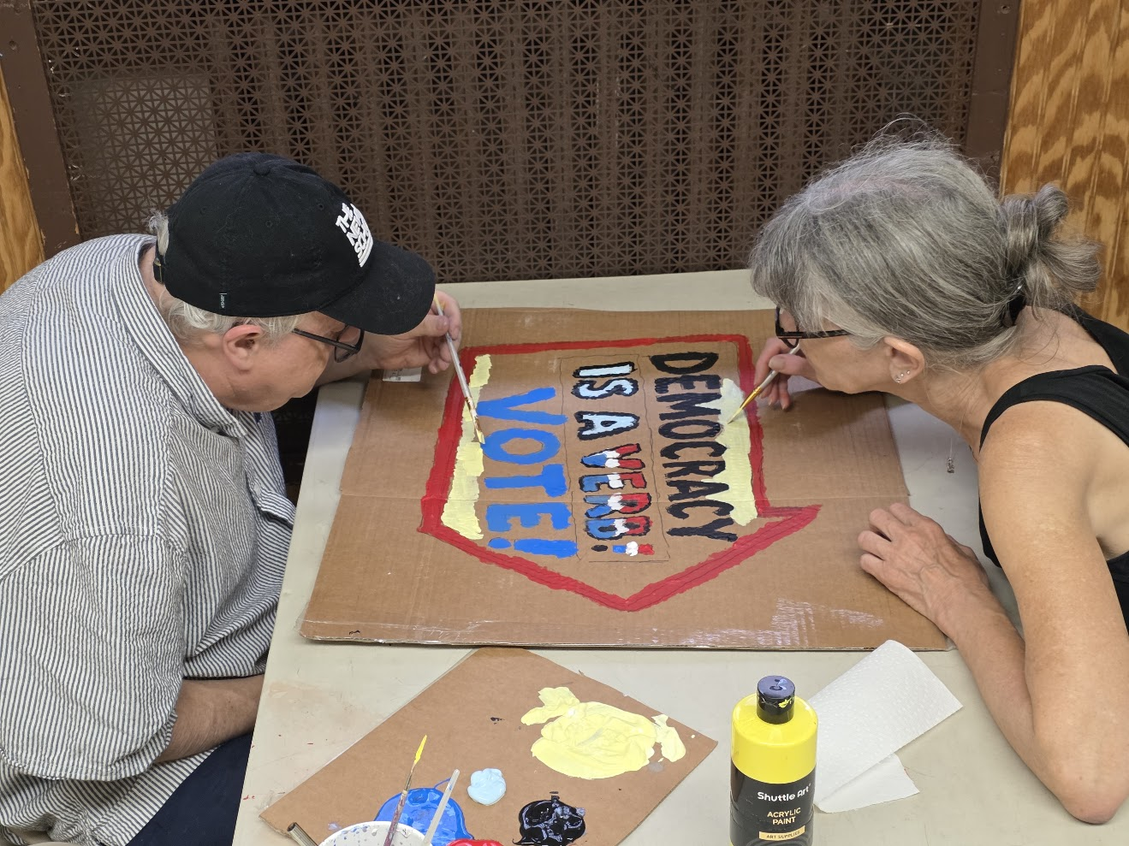

MUSIC, PERFORMANCE AND CULTURE
A VOTEFEST should feel alive before someone even knows exactly what the event is.
Music and performance help transform a collection of information tables into an actual community festival.
Depending on the location and resources, consider:
- live musicians
- singers
- DJs
- community performers
- youth performers
- occasional brief speakers on voting rights, election protection or related subjects
No politicians - although they can happen to be having a rally across the street.
Keep speeches short.
The purpose of the performance area is to create energy, not to make attendees stand through a long program. Music should continue through much of the event whenever feasible. Position the music as far from the information tables as possible so people can still have conversations.
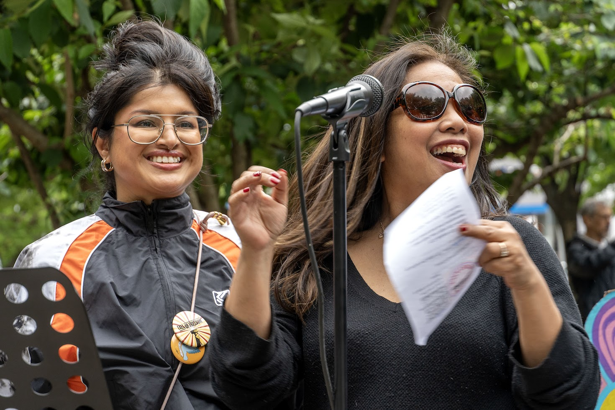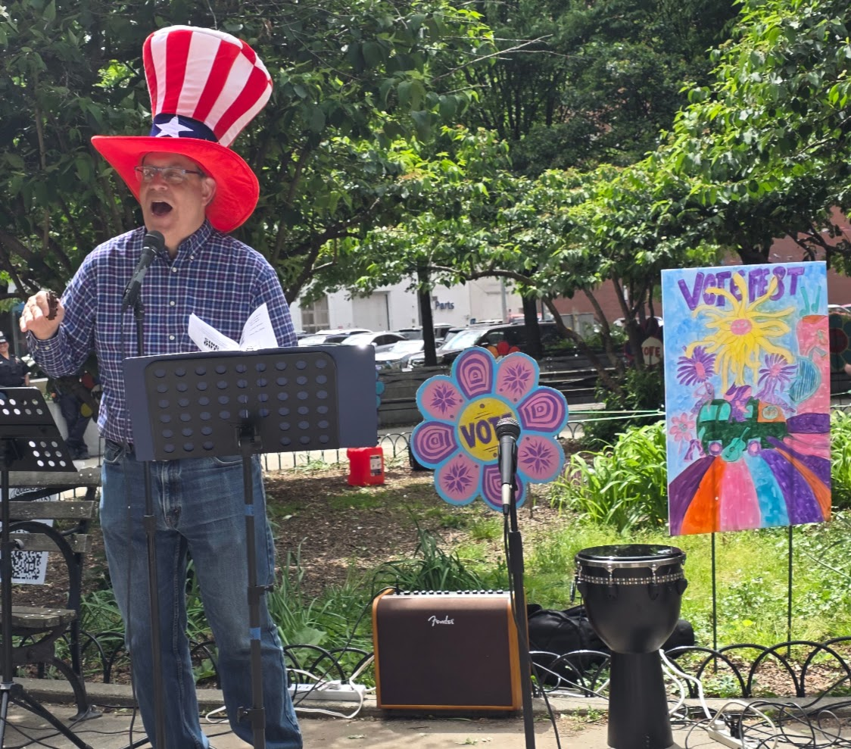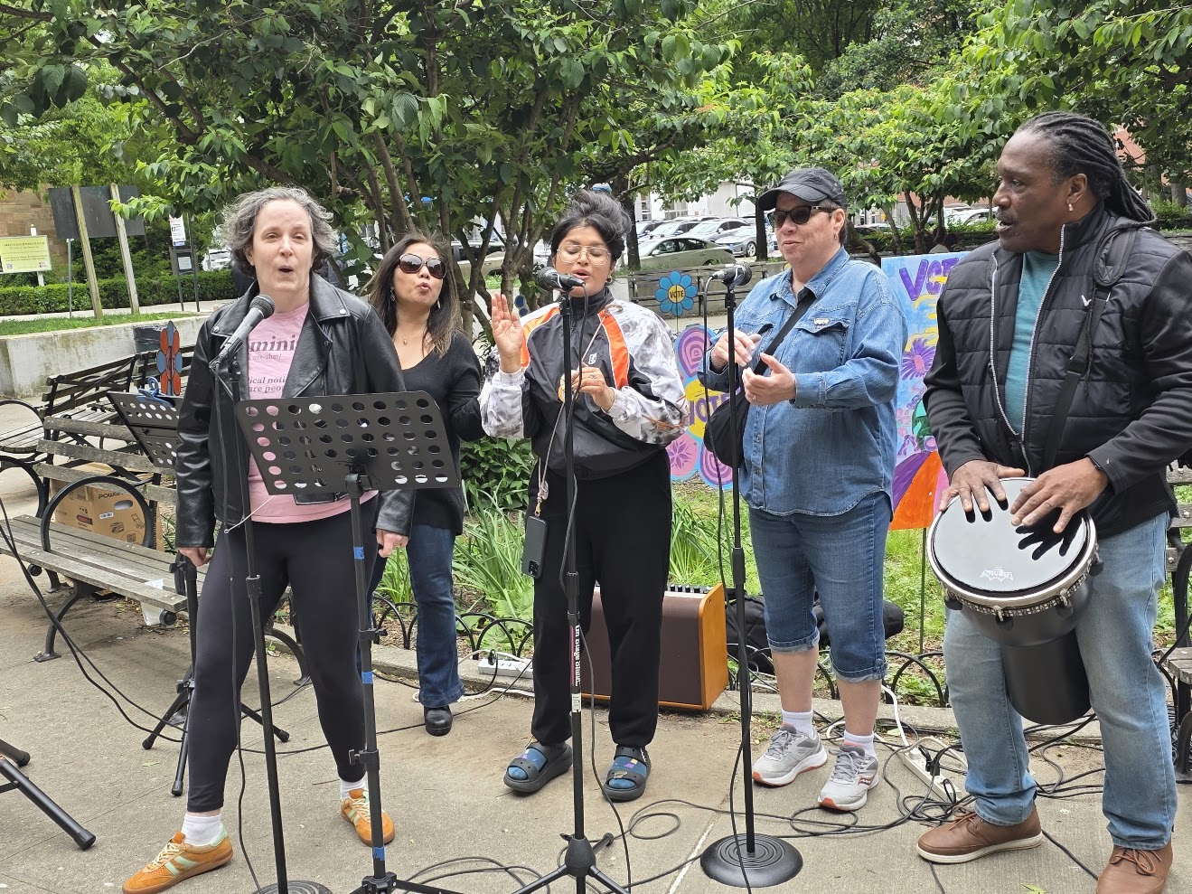

FOOD AND HOSPITALITY
Food helps create the feeling of a community gathering.
We recommend empanadas or another finger food from a local small business - something that is easy to serve, does not require utensils and is forgiving about being served at different temperatures.
Also remember:
- water
- napkins
- trash bags
- cleanup supplies
- a plan for disposing of garbage
Someone should be specifically responsible for hospitality and cleanup.
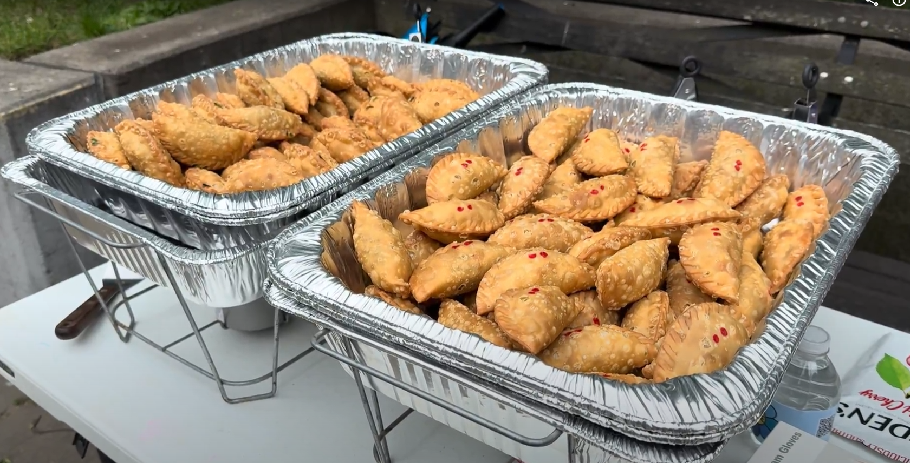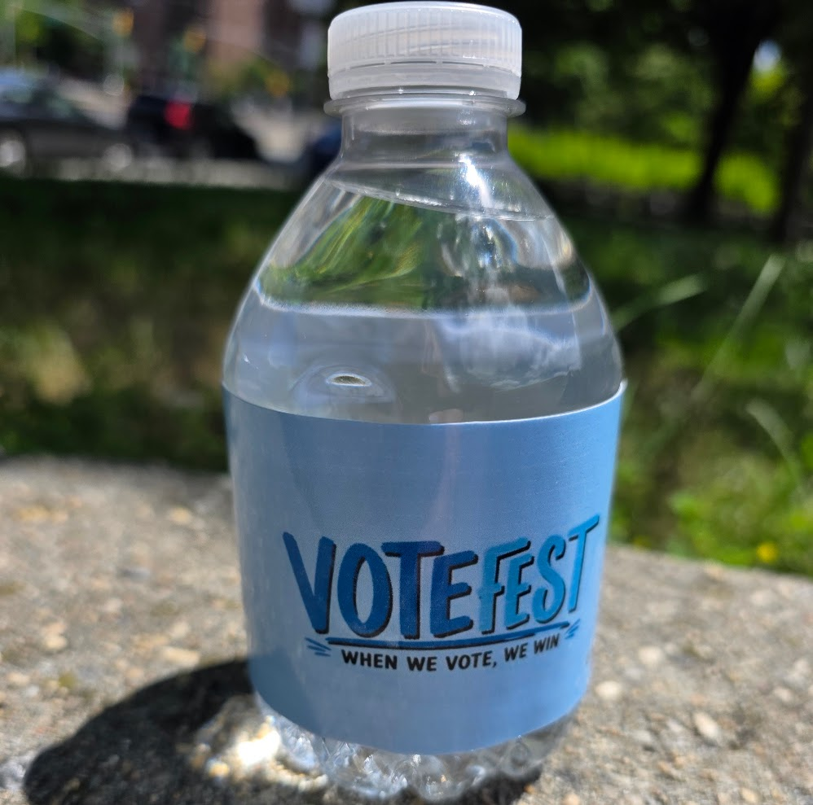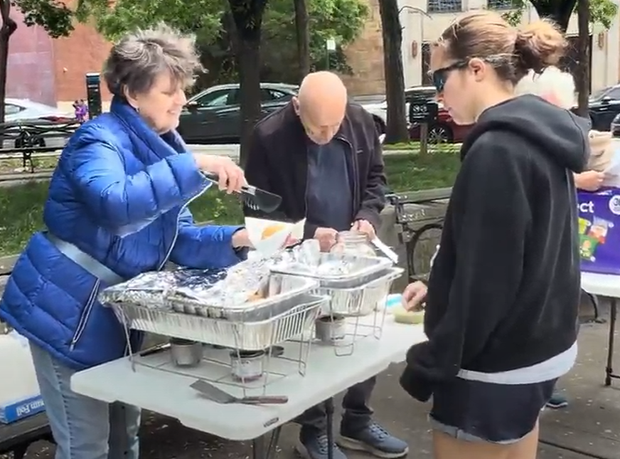

THE PHYSICAL LAYOUT
Do not simply line up ten tables. Create recognizable areas of activity.
A full VOTEFEST might include:
WELCOME / WHAT IS VOTEFEST?
Your volunteers - greet people and explain what is happening.
REGISTER + VOTING PLAN
Partner organization - voter registration, registration checks and voting plans.
VOTING HELP
Partner organization - accessibility, senior assistance and other voting resources.
ELECTION PROTECTION
Partner organization - know-your-rights information and volunteer opportunities.
TAKE ACTION
Your volunteers - ways to canvass, volunteer, organize and get involved after the event.
COMMUNITY PARTNERS
Tables from additional participating organizations.
ART + PARTICIPATION
Button making and/or mini VOTE flowers, the WHY WE VOTE wall, and the community mural.
MUSIC / PERFORMANCE
Position this far enough from the tables that it does not interfere with conversation.
FOOD / COMMUNITY SPACE
A place to eat, sit and talk.
FUNDRAISING
If you are fundraising for your own organization, the fundraising table is best placed next to the free food and drinks.
Use the VOTEFEST signs and VOTE flowers throughout the site to visually connect the different areas.
Attendees should immediately see that there are things to DO, not just tables where people hand them flyers.

BUILDING AN AUDIENCE BEFORE THE EVENT
VOTEFEST outreach should begin well before the festival itself.
Smaller voter-engagement activities can take VOTEFEST into the community and build recognition before the main event:
- farmers-market and community-event canvassing
- business-district canvassing
- neighborhood tabling
- door-to-door voter outreach
- visibility actions
- the VOTEFEST Art Build
- social media and email
- flyers and palm cards
- community calendars
- local press and radio
The message should not simply be:
"Come to our event."
Use the outreach itself to begin the voter engagement. Talk to people about voting. Tell them what resources will be available. Invite them to participate and volunteer. Find out what voters are thinking, what might be keeping them from going to the polls.
By the time the festival happens, VOTEFEST should already have begun.

STAFFING
Assign clear responsibility for the major areas.
Event Lead - overall coordination
Logistics - permits, site, tables, chairs, power and setup
Partners - recruiting and communicating with participating organizations
Voter Engagement - coordinating registration, voting-access and election-protection partners
Art - Art Build, VOTEFEST decoration, participatory art and take-home activities
Programming - musicians, performers and speakers
Volunteer Coordination - recruitment, assignments and check-in
Canvassing Field Manager - Organizes VOTEFEST canvassing
Communications - email, social media, press, flyers and community calendars
Hospitality - food, water and cleanup
For a smaller VOTEFEST, one person can handle more than one area. What matters is that every responsibility has an owner.

BASIC EQUIPMENT AND SUPPLIES

Basic Setup
- tables and chairs
- table coverings
- tents or canopies if needed
- extension cords and power strips
- tape, zip ties and scissors
- weights for outdoor displays

Sound
- speaker or PA system
- microphones
- microphone stand
- cables and power

Voter Engagement
Most voter-registration and voter-education partners will bring their own materials.
Have available:
- pens
- clipboards
- QR codes
- your organization's signup materials

Participatory Art
Depending on the activities you choose:
- button machine and button components
- paper circles/templates and markers
- pre-cut mini flower shapes and stems
- WHY WE VOTE wall and markers
- park-bench mounting structure if needed
- community mural and painting supplies

Hospitality
- water
- food if offered
- napkins
- garbage bags
- cleanup supplies

THE QSNK VOTEFEST LOAN LIBRARY
Queens Says NO KINGS wants other groups to be able to reproduce VOTEFEST without purchasing everything from scratch.
Subject to availability, QSNK can loan:
- branded VOTEFEST artwork and signs
- large VOTE flowers
- reusable GOTV artwork
- WHY WE VOTE wall setup
- park-bench mounting structure
- button-making equipment
- display materials
- digital VOTEFEST graphics and templates
- sample flyers, palm cards and outreach materials

QSNK can also share Art Build examples, mini VOTE flower templates, mural ideas and instructions for making additional pieces. Other equipment may sometimes be available through QSNK volunteers or partner organizations. Groups borrowing materials should designate one person responsible for pickup, care and return.
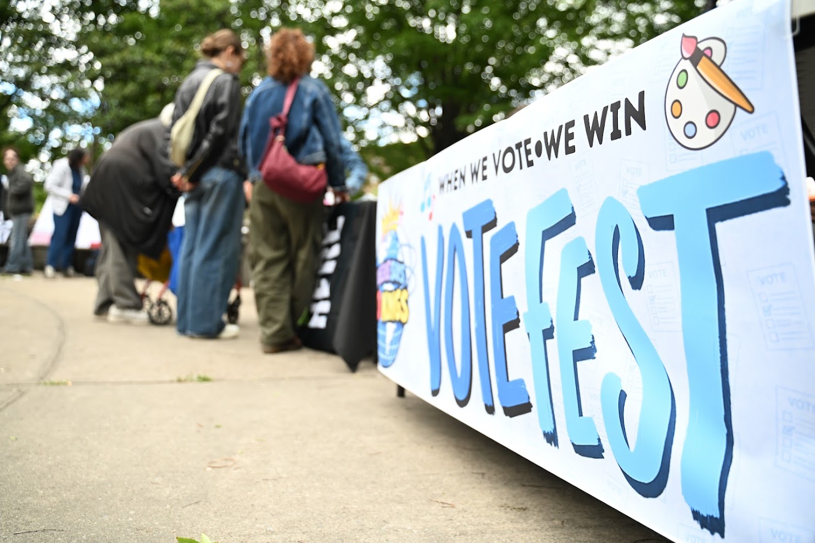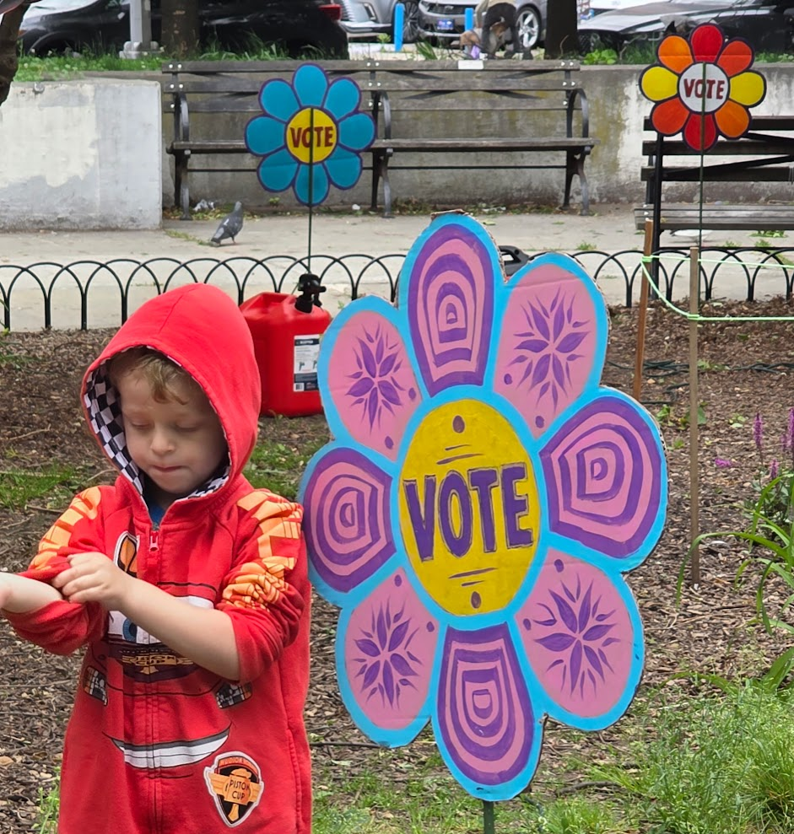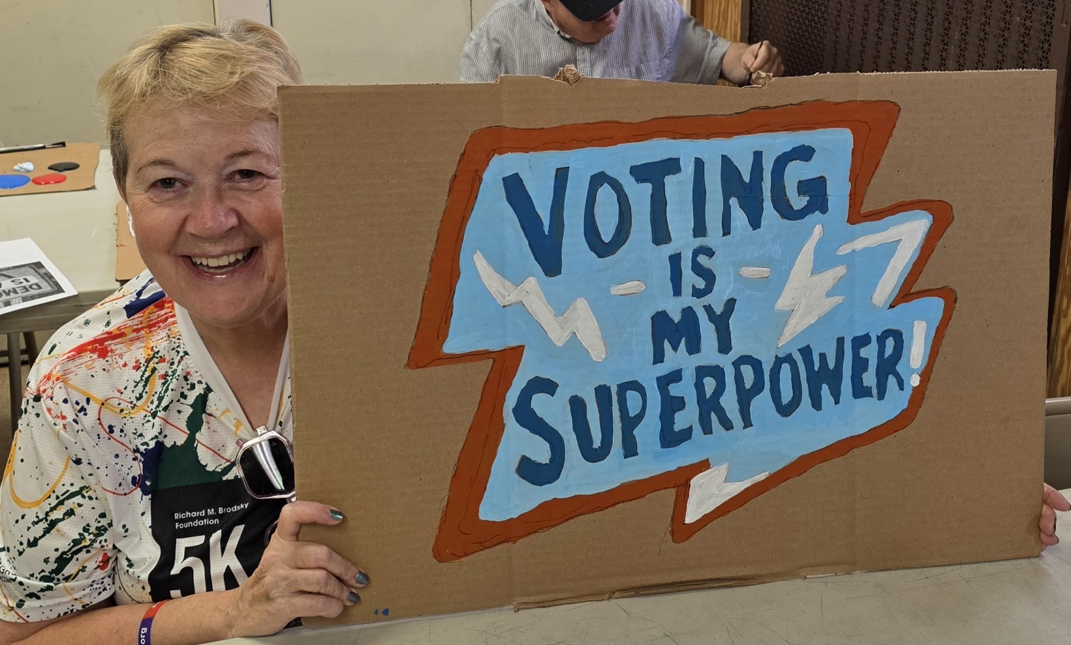

A SUGGESTED PLANNING TIMELINE

6-8 Weeks Before
- Choose the location and date.
- Establish the planning team.
- Begin permits if required.
- Invite major voter-engagement partners.
- Begin recruiting performers.

4-6 Weeks Before
- Confirm partners.
- Develop the site layout.
- Recruit volunteers.
- Begin publicity.
- Schedule the Art Build.
- Determine equipment needs.

2-4 Weeks Before
- Hold the Art Build.
- Begin community canvassing and tabling.
- Distribute flyers and palm cards.
- Submit the event to community calendars.
- Increase social-media and email promotion.
- Confirm sound, tables, chairs, food and supplies.

Final Week
- Confirm partners and performers.
- Finalize volunteer assignments.
- Create the setup plan.
- Pack supplies.
- Confirm pickup of borrowed VOTEFEST materials.
- Continue canvassing and promotion.

Event Day
- Arrive well before the published start time.
- Put up the large VOTEFEST visuals early so the site immediately begins to look like a festival.
- Set up voter-engagement and partner tables.
- Set up the WHY WE VOTE wall, mural and make-and-take art.
- Test the sound system.
- Brief volunteers on what VOTEFEST is and how to direct people to the different resources.
- Then welcome the neighborhood.

